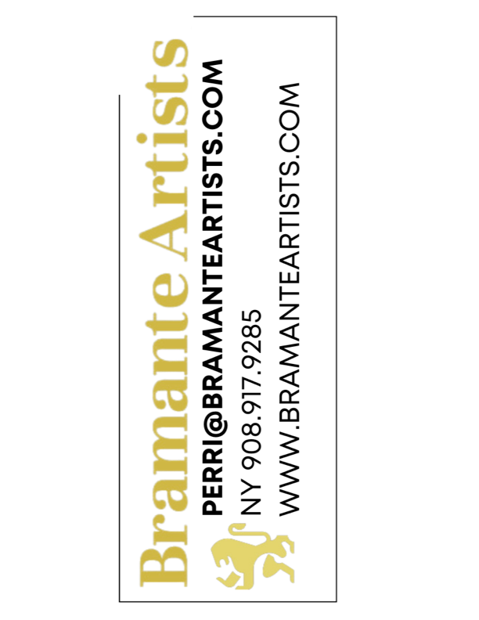
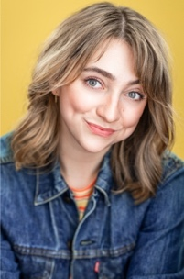
Maggie Anne Gillette
maggieannegillette.com
EMC

Theatre Credits
Much Ado About Nothing Beatrice SCAD Museum of Art Francesca Mintowt-Czyz
Twelfth Night Olivia Clark Theatre Catherine Weidner
The Matchmaker Mrs. Irene Malloy The Katharine Hepburn Glenn Bassett
Seussical the Musical Gertrude McFuzz Warner Theatre Richard McKenna
Women’s Honor Cheated One Met Playhouse Rachael Langton
Wyldwood Players Lady Elizabeth Clinton Sterling Ren. Festival Gary Izzo
Morning Anna Ithaca College Jacob Stuckleman
The Moors Moor-Hen Ithaca College Tyler Struble
Can Can Young Women/Housewife Dillingham Center Aaron Roberts
Happiness and Cheer Stanley Dillingham Center Ava DeFrancesco
Essay Pixie Dillingham Center Liana Pavane
Camp Falcon Springs Anna. M Honestly Speaking Inc. Audrey Lang
Trolls x CAMP Trolls Performer CAMP Stores Tom Salamon

New Works
Green Gables Myra Pringles Hangar Theatre Kevin Sullivan
Lost Lodge Lead The Katharine Hepburn Terri Corrigliano

Film Credits
Legend of Lost Warwick Mistress Florence Carre (Supp) Pontum Productions Gordon Boudreau
I know Anne (Lead) Sacred Heart University Jesus Rodriguez
Euphorium Hale (Lead) Ithaca College Ali Walker
At the Fall of the Curtain Jenna (Supporting) Ithaca College Josh Wahl

Education & Training
Ithaca College – Ithaca, NY - BFA Acting ’19
• Acting: Cynthia Henderson, Paula Murray-Cole, Norm Johnson, Austin Jones, Marc Gomes (camera)
• Classical Theatre/Shakespeare: Catherine Weidner, Greg Bostwick, Kathleen Mulligan
• Farce/Comedy: Melanie Jessop
• Movement: Paula Murray Cole, Dean Robinson
• Dance: Tucker Davis (Jazz), Elizabeth Livesay (Tap)
• Stage Combat: Brett Yount
• Dialects/Speech/Voice: Kathleen Mulligan, Paula Murray-Cole, Susannah Berryman, Erica Steinhagen
Neutral Chaos – New York City, NY
• Unarmed Stage Combat - Rob Aronowitz
• Single Sword & Quarterstaff – Jason Paul Tate, Rob Aronowitz, Jake Guinn
• Sword & Shield (currently training) – Mike Magliocca
The School of Creative and Performing Arts – Burlington, VT- Acting - Casey McClellan

SKILLS SAFD Unarmed/Single Sword/Quarterstaff Certified, Interactive and Immersive Theatre Performance Certified, Valid DL and Passport, IPA, Rasa Boxes, Swimming, Biking, Yoga, Beginner Piano, Beginner French Language, Beginner ASL, French/Standard British/Southern Dialect, Tongue Tricks, Burp on Command, Sneezing on Command, Chicken Clucking.

